**Advanced Software Engineering**

**Take Home Exam**

**Tourist Map Finder**

**Introduction:**

Tourist Map Finder is a web application which allows users to create tourist routes all over the world from the places registered at FourSquare. Any kind of media content, maps and descriptions can be added for each place. While walking through, the user checks in with the information provided in the application and gets relevant content about the place. This app may help you choose the best route and keep a record of your travels. When it is complete, or at any time, you can see a map of all the spots you visited and share your route.

**1. Design:**

* Architecture Diagram:

Creates Routes

Routes list

Route Description

Adding images of the routes

 Place of interest

Database

Check-in

Place Description

* Class Diagram:

Class: Database

Username

Password

Validates()

StoreRoute()

DeleteRoute()

AddRoute()

updateProfile()

Class: User

Username

Password

createsRoutes()

registers()

login()

chooseAndWalkThroughARoute()

TraceARoute()

updateProfile()

Class: MapFinder

Source

Destination

getDirections()

pickRoutesFromList()

**2. Features Implemented:**

* Web Services:

I used Google Maps API and Foursquare API to create a route between two end points to show a map. I also provided login service for a user to get registered and view his account. Finding routes when source and destination are provided is the main motto of the maps.

* Database:

I used SQL server in order to store the data, validate the username and password provided by the user and also to store all the information pertaining to maps like saving images of routes, routes list etc.

**3. Include Screenshots of the Features:**

Home page:

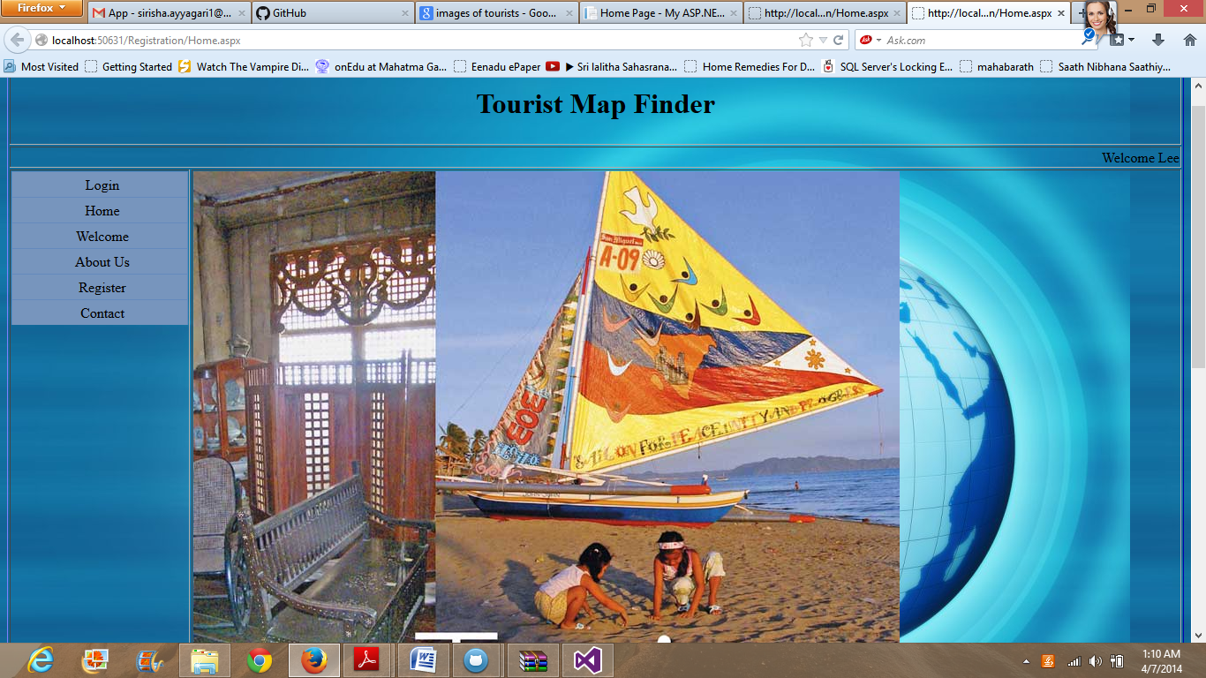

Register Page:

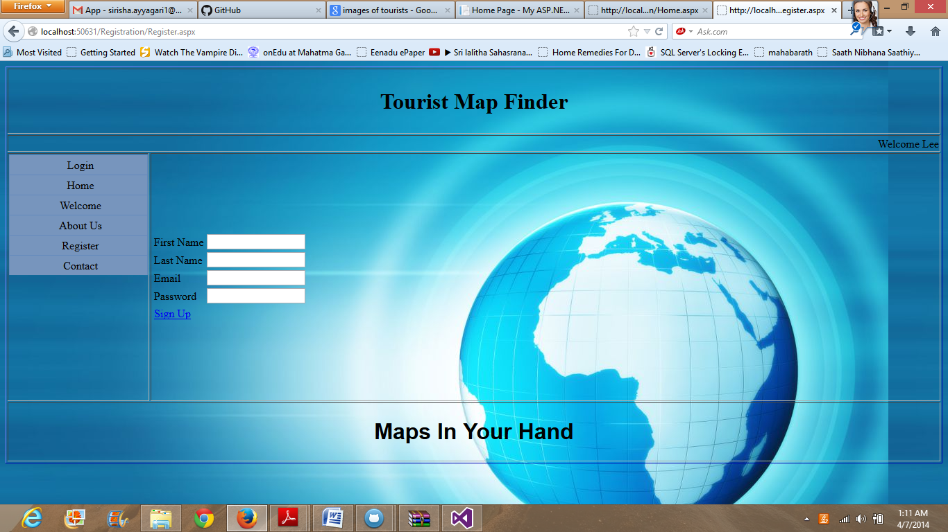

Login page:

As of now, I have provided user name and password as “Lee”.

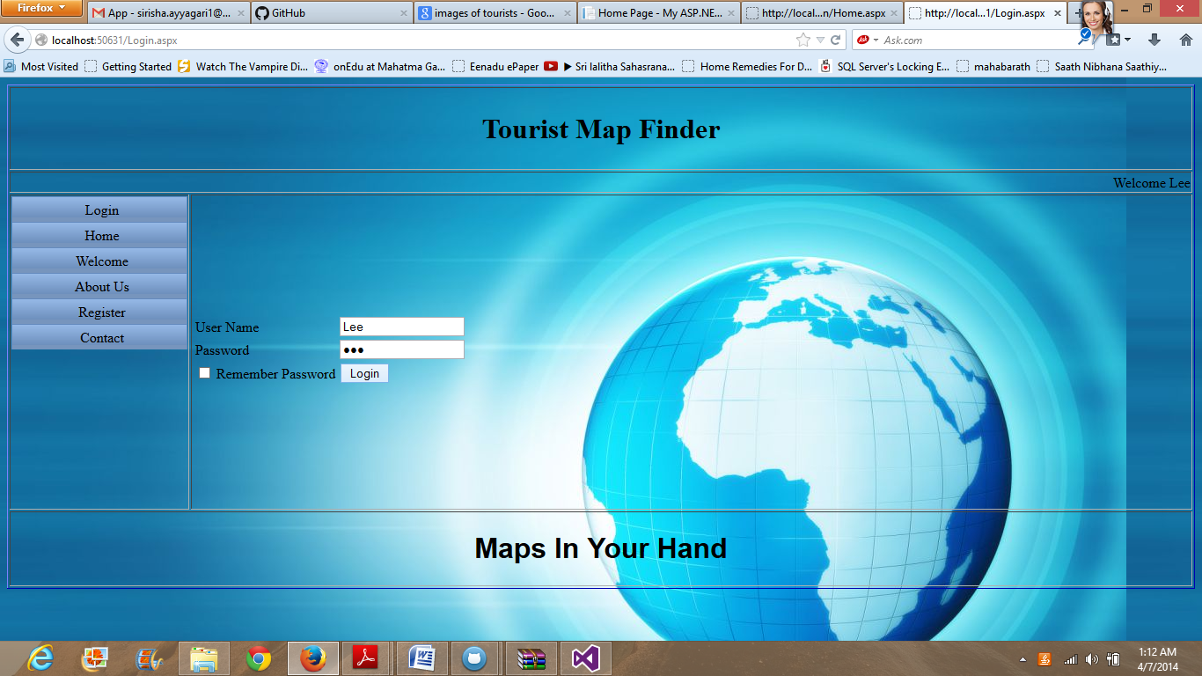

But, it does show a message “invalid password” when username and password are not correct.

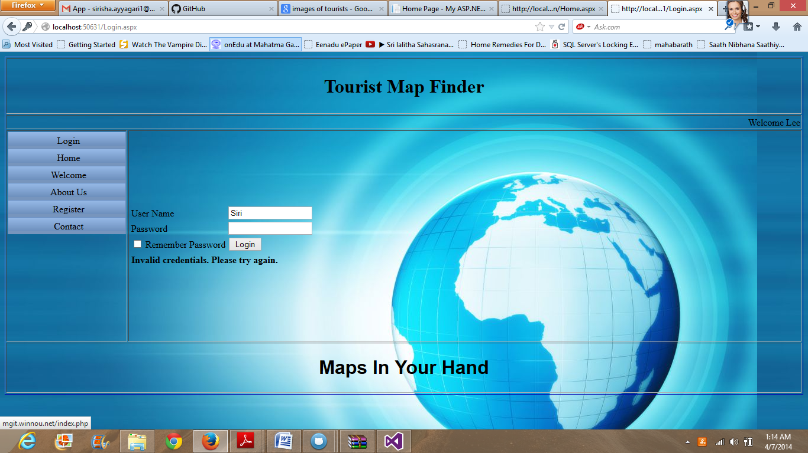

After Login

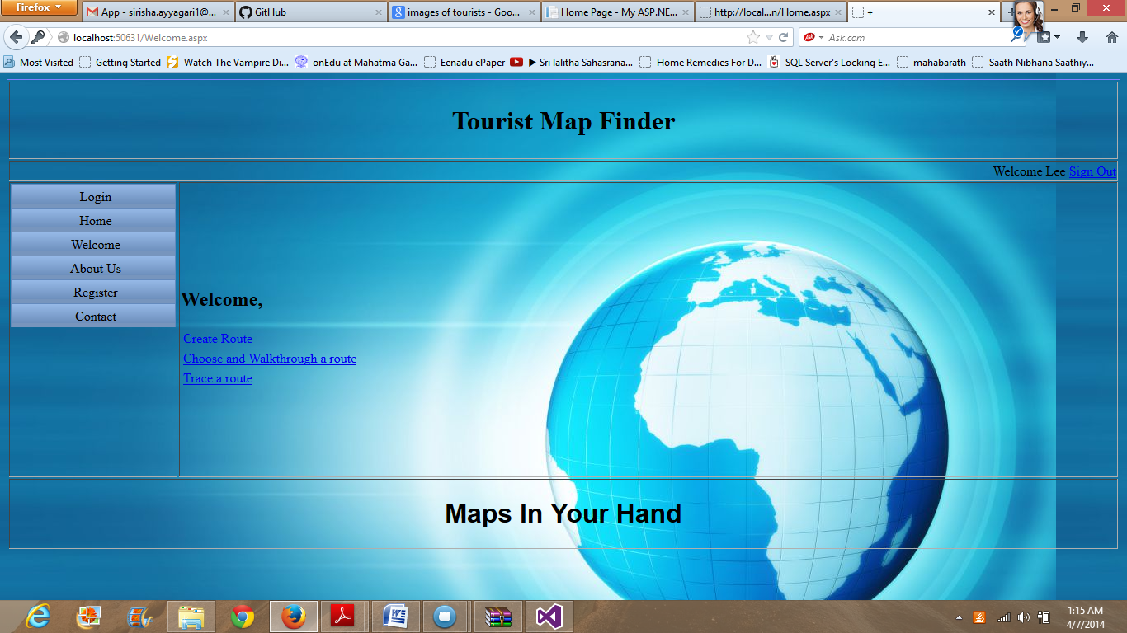

Create a Route Page:

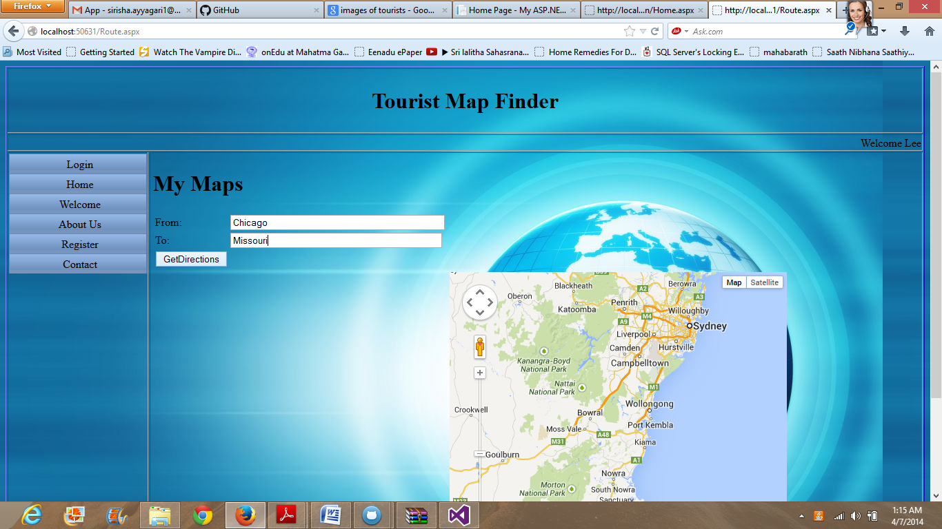

It shows maps and directions

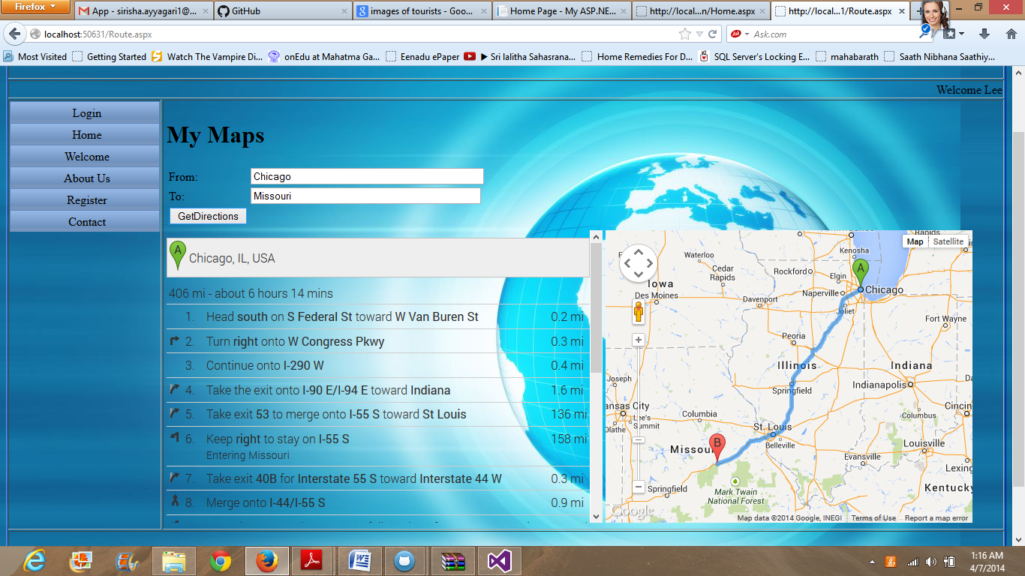

Choose and walk through a route:

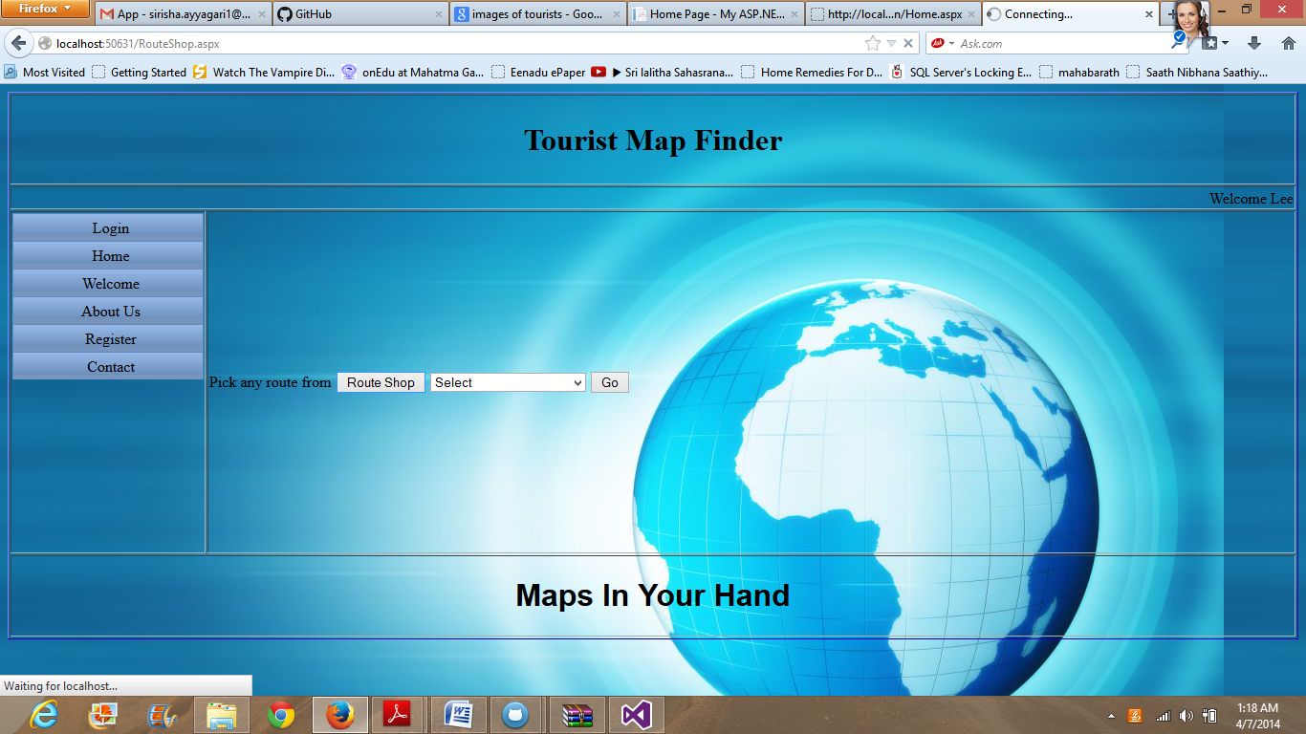

About us Page:

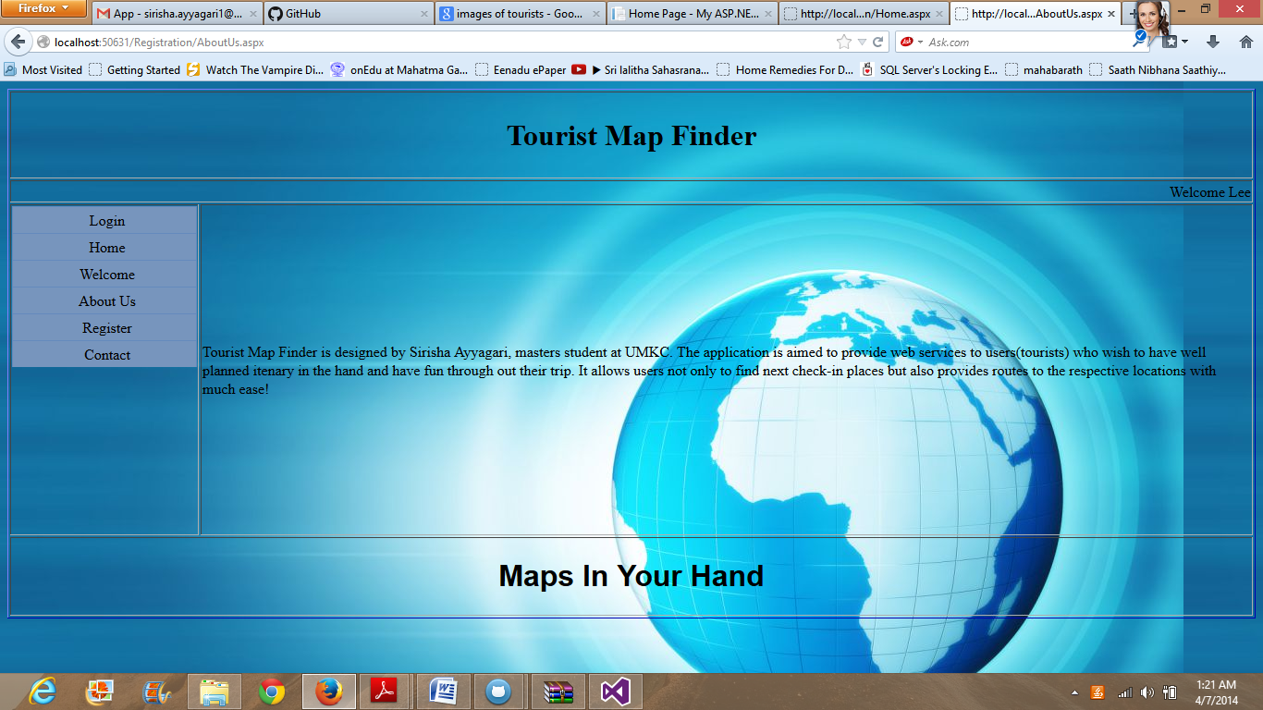

Contact Page:

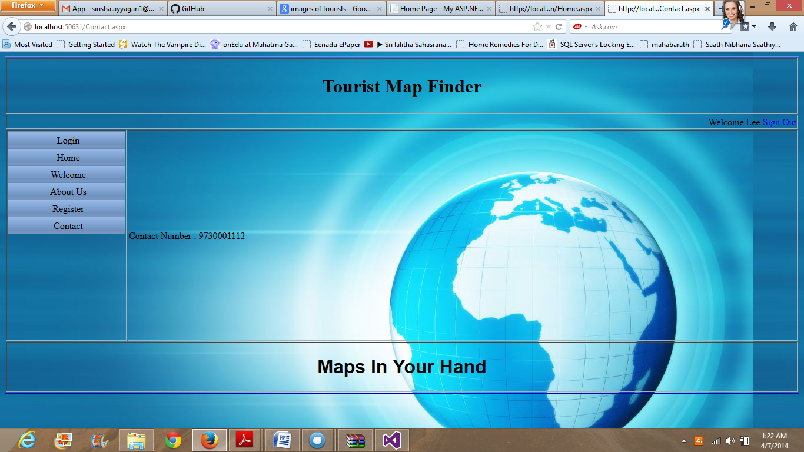

**4. Include all the Web Service and Web Site URLs:**

* <https://developer.foursquare.com/start/search>
* <https://developers.google.com/maps/documentation/>

**5. Include your midterm Github URL:**

**6. Limitations:**

* Although this map is very much useful to find route between two end points, it barely has services for users to communicate with each other.
* This application lacks the facility to include popular websites like facebook, twitter, gmail etc.

**7. References:**

* <https://foursquare.com/>
* <https://developer.foursquare.com/start>
* <https://developers.google.com/>
* <http://en.wikipedia.org/wiki/Google_Maps>
* <http://www.w3schools.com/googleapi/default.asp>